Volunteer of the Month
Girl Scouts of Northern California wishes to thank

for your outstanding service and dedication to Girl Scouts.

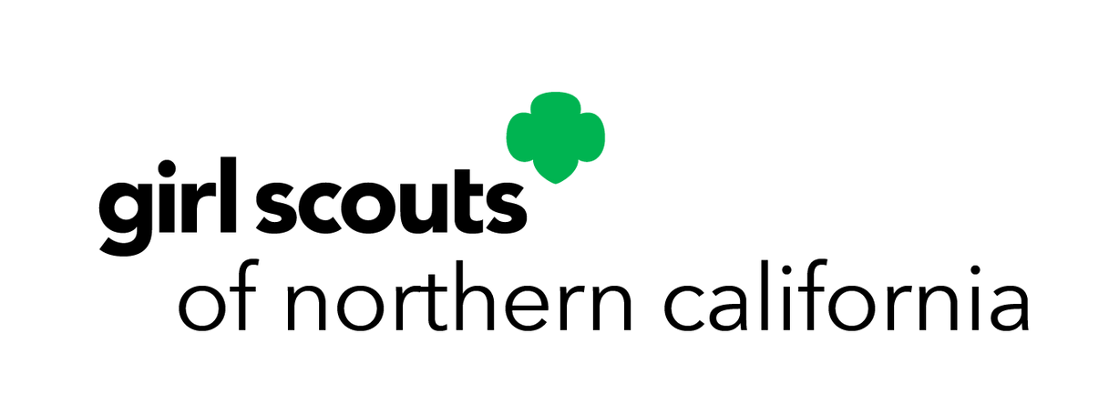
Service Unit Recognition Coordinator
Date



Volunteer of the Month
Girl Scouts of Northern California wishes to thank

for your outstanding service and dedication to Girl Scouts.

Service Unit Recognition Coordinator Date

