Girl Scout Planner
Troop Fundamentals and Year Planner

It is time to plan your best troop year! Download and use this Word document to plan and calendar activities for each of the six elements of the Girl Scout Troop Fundamentals. TIP: Upload to Google Drive to share with your Troop Leadership Team.
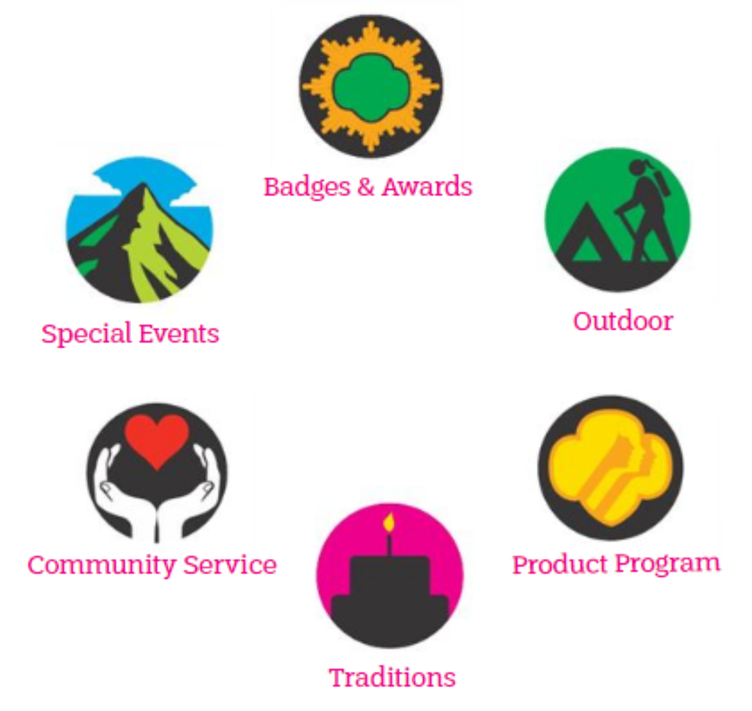
There are two parts to this planning calendar:
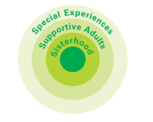
- Part 1 - Girl Scout Troop Fundamentals: Fill out each section to plan a fun and well-rounded year. Use it to track your activities in the six elements of the Girl Scout Troop Fundamentals. Try to complete at least one activity for each element – remember you can combine activities. Taking a hike to complete an outdoor badge counts for both Outdoors and Badge & Awards. Save this document to celebrate all you have done. At year-end, you will have the opportunity to submit it for recognition of your troop’s accomplishments.

- Part 2 – 2023-2024 Troop Year Planner: This is a planning calendar to help you and your girls plan and organize activities by month within a typical troop year. The calendar shows you when things happen in Girl Scouts, from celebrating Girl Scout’s Founders Day to participating in the Cookie Program. You can use this planner on its own, along with your Volunteer Toolkit meeting planner for planning badge work at meetings, or plug dates into your own personal calendar.
PART 1 – Girl Scout Troop Fundamentals
PART 1 – Girl Scout Troop Fundamentals
Troop Fundamentals | What activities are you planning? | What do you need to do to prepare for this activity? (Materials needed, who will help, timeline, etc.) | Month completed:

Aim to earn at least three-five awards. This could be badges, Journeys, awards, or one of each. Find out what your troop is interested in and look in the Volunteer Toolkit for requirements.

Aim to complete at least one outdoor activity, but there is no limit if you want to do more! Take a trip to a local park, have a cookout, or go camping! Don’t forget to check the Safety Activity Checkpoints!

Year One Troops should aim to take part in the online Fall and Cookie Product Programs to earn troop proceeds and girl rewards. Year Two is a great time to add in booth selling during the Cookie Program.
Troop Fundamentals | What activities are you planning? | What do you need to do to prepare for this activity? (Materials needed, who will help, timeline, etc.) | Month completed:

Aim to do at least one Girl Scout tradition activity at every meeting. For example, sing Girl Scout songs, do a friendship circle, perform a flag ceremony, or celebrate Girl Scout special days like the Girl Scouts birthday (March 12). Wearing your uniform is a tradition too!

Aim to do at least one Community Service project. Find someone or thing the girls really care about helping. Identify a community need by starting with your own school or neighborhood and build from there.

Aim to do at least one special event each year. For example, your troop could attend a service unit event, or go on your own field trips such as visiting the fire department, farmer’s market, or pet shelter.
Girl Scout Troop Year Planner 2021-2022
Girl Scout Troop Year Planner 2023-2024

Part 2 – Troop Year Planner: Use this troop year calendar to plan the monthly activities you will be completing throughout the year. Key Girl Scout events and themes are included to give you an idea of the events and opportunities in a typical troop year.
July | August | September
- Participate in troop and camp activities  - Check out the Events Calendar  - Back to troop (are Girls/Adults Registered?) Check out our Registration and Renewal resources  - Login to the Volunteer Toolkit (VTK) and start planning your year – July 10  - Make reservations/register for GSNorCal Fall activities in the Events Calendar  - Site property reservations open for service units for Dec. 1 - May 30 – Jul. 1 – Aug. 1 | - Participate in troop and camp activities. Check out the Events Calendar  - Friendship Day - First Sunday in August  - National S'mores Day - Aug. 10  - Women's Equality Day - Aug. 26 | - Individual property reservations open for troops and service units for Dec. 1 - May 30 – Sept. 1  - Program registration opens Sept. 1  - Host family/girl meeting troop – kick-off  - Investiture ceremonies to welcome new girls and other fall ceremonies  - Plan fall badge/community service projects  - Troop Volunteer Fall Take Action Program Kickoff– Sept. 6  - Fall Take Action Program–Sept. 30–Nov. 12
October | November | December
- Make a Difference Day – Oct. 24  - Founder’s Day/Juliette Low’s Birthday – Oct. 31 | - Volunteer and Give Back during the holidays  - World Kindness Day – Nov. 13  - Get outside for National Take a Hike Day –Nov. 17  - Plan holiday celebrations | - Volunteer and give back during the holidays  - National Brownie Day - Dec. 8  - Plan holiday celebrations

January | February | March
- Registration for summer camp opens – Jan. 17  - Plan for Cookie Program by working with girls to set goals and plan activities, secure troop volunteers to help.  - Plan a family meeting for Cookie Program  - New spring GSNorCal programs open in Events Calendar | - 2024 Cookie Program – TBD  - Site property reservations open for service units for Jun. 1 – Nov. 30 – Feb. 1 – Mar. 1  - Earn the Cookie Entrepreneurial Family Pin  - Black History Month  - Plan spring outdoors, community service and/or special event field trips for troop  - Girl Scout’s World Thinking Day – Feb. 22 | - Women’s History Month  - International Women's Day - March 8  - National Girl Scout’s Birthday – March 12  - Girl Scout Week – the week of March 12
April | May | June
- Early bird Girl Scout membership renewal  - Individual property reservations open for troops and service units for Jun. 1 – Nov. 30 – Apr. 1  - Volunteer Appreciation Month  - Girl Scout Leader’s Day & Earth Day – April 22  - If your troop is aging up into the next program level (e.g. Daisies going to Brownies), plan to earn your Bridging Award  - Find out about service unit or other local summer activities for Girl Scouts | - Host a year-end awards ceremony or year-end party to celebrate your achievements  - Plan your bridging ceremony or attend a local bridging put on by your service unit  - Remind girls and volunteers to renew during Early Bird renewal  - Plan a fun summer troop activity | - Participate in summer troop activities and/or camp  - Flag Day - June 14  - Prepare and submit your Troop Financial Report  - Make sure youth and adults are renewed for another year of fun!  - Renew your troop leadership role so you will have access to the Volunteer Toolkit (VTK) to start planning for next year.

